Middle School Energy Skate Park Lesson
Name_________________________________Date____________Period____________

ENERGY SKATE PARK

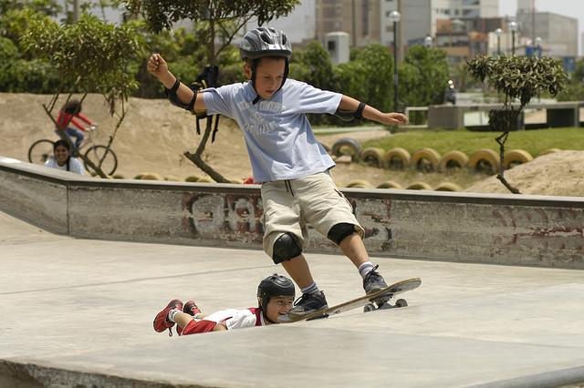

Learning Goals:
- Develop a model to describes how when distance changes, different amounts of potential energy are stored in a system.
- Examine how kinetic and potential energy interact with each other.
- Interpret graphical displays of data to describe the relationships of kinetic energy to the speed of an object
- Describe how energy can be transformed and apply to real world situation.
- Examine how friction affects the motion of objects

Instructions: Open up the PhET simulation “Energy Skate Park Basics.”
Either type in http://www.colorado.edu/physics/phet/dev/html/energy-skate-park or Google “PhET Energy Skate Park Basics.”

PART A-Designing a Skate Park

- Click on the “Playground” tab. Explore the simulation by clicking and dragging the tracks in order to make different loops and hills.

- List what variables you are able to change in the simulation:

_________________________________________________________________________

- Create a track with at least on hill and one loop. Draw your design in the space below. DO NOT start your skater on your track until you draw it!

- Place your skater at the top of the track. Did your skater complete the track? Explain what happened in the space below:

_________________________________________________________________________
_________________________________________________________________________
_________________________________________________________________________
_________________________________________________________________________

PART B-Potential Energy and Kinetic Energy

- Click on the “Intro” tab. Explore the simulation. List the variables that you can change in the space below:

_________________________________________________________________________

- Using the simulation, describe or draw how you can change the amounts of potential energy in the table below. (make sure that you have either the pie chart or bar graph checked):

Most Potential Energy
Least Potential Energy
- Using the simulation, describe or draw how you can change the amount of kinetic energy in the table below:

Most Kinetic Energy
Least Kinetic Energy
- In the table below, describe what happens to the potential and kinetic energy of the skater when he is on different parts of the track (make sure that you have either the pie chart or bar graph checked):

Position of Skater | Amount of Potential Energy | Amount of Kinetic Energy
High on the track | IncreasesDecreases | IncreasesDecreases
In the middle of the track | IncreasesDecreases | IncreasesDecreases
At the bottom of the track | IncreasesDecreases | IncreasesDecreases

- What claim can you make about the relationship between the relationship between kinetic energy and potential energy?:

_________________________________________________________________________
_________________________________________________________________________
_________________________________________________________________________
- What is your evidence?

_________________________________________________________________________
_________________________________________________________________________
_________________________________________________________________________

SPEED, POTENTIAL ENERGY, KINETIC ENERGY

- On the diagram below, label where you think the speed of the skater will be the greatest.

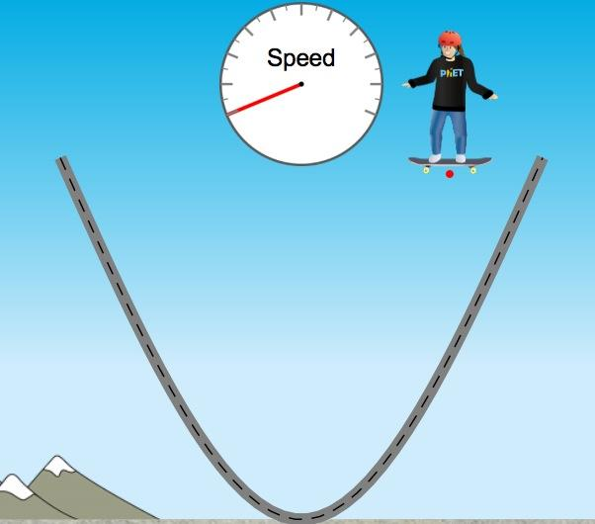

- In the table below, describe what happens to the speed of the skater when he is on different parts of the track (make sure that you have speed checked):

Position of Skater | Amount of Potential Energy | Amount of Kinetic Energy | Speed of Skater
High on the track | IncreasesDecreases | IncreasesDecreases
In the middle of the track | IncreasesDecreases | IncreasesDecreases
At the bottom of the track | IncreasesDecreases | IncreasesDecreases

- What claim can you make about the relationship between the relationship between potential energy, kinetic energy, and speed?

_________________________________________________________________________
_________________________________________________________________________
_________________________________________________________________________

- What is your evidence?

_________________________________________________________________________
_________________________________________________________________________

TOTAL ENERGY

- In the space below, find ways you can change the total energy in the simulation.

_________________________________________________________________________

PART C-Friction

- Click on the “Friction” tab. Explore the simulation. List the variables that you can change in the space below:

_________________________________________________________________________

- In the table below, describe the motion of the skater when you change the amount of friction (make sure that you have either the pie chart or bar graph checked):
:
Action | Motion of Skater | Observations
Lots of friction | IncreasesDecreases
No friction | IncreasesDecreases

- Make a claim about how friction affects the motion of the skater in the space below:

_________________________________________________________________________
_________________________________________________________________________
_________________________________________________________________________

- What is your evidence?
_________________________________________________________________________
_________________________________________________________________________
_________________________________________________________________________

PART D-Designing a Skate Park

- Click on the “Playground” tab. If the skater was not able to complete the track, revise your design. Make sure to include on hill and one loop. Draw your revised design in the space below:

- On your design, label the points on the track where the potential energy of the skater is the greatest (PE).

- Label the points on the track where the kinetic energy of the skater is the greatest (KE).

- Label the points on the track where potential and kinetic energy are equal (PE=KE).

- Label the points on the track where speed is the greatest (S).

- In the space below, explain how potential energy, kinetic energy, and friction affected your track design:

_________________________________________________________________________
_________________________________________________________________________
_________________________________________________________________________
_________________________________________________________________________
_________________________________________________________________________
_________________________________________________________________________
_________________________________________________________________________
_________________________________________________________________________
_________________________________________________________________________

Summary, Reflection:
1 | Scientific concepts covered in the simulation:
2 | Examples of how each was used in the simulation:
3 | Questions I still have, interesting things I learned:

